Project Proposal

Joel Jose, Ibrahima Bah

In order to keep our valuable belongings safe, we keep them in lockers and safes and lock them with a key. But one problem with keys is they can be duplicated by people and the duplicate key can be used to open these locks. One approach to overcome this issue would be by using a wireless key.

We will be making a safe lock that can only be activated by a wireless key. It will be using ad hoc based topology. It will be a sliding lock attached to the inside of the safe, and in order to lock or unlock it the button on the key would have to be pressed within the vicinity of the safe. The signal would be received by a raspberry pi and it would send a signal to a battery powered dc motor on the inside of the safe that would slide the lock. If the key goes out of range and back in range again, the lock would slide again to either lock or unlock the safe.

Parts needed:

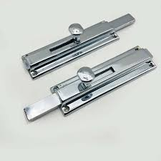 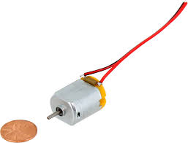

Lock Motor

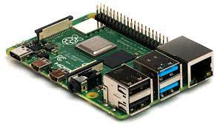

Raspberry pi

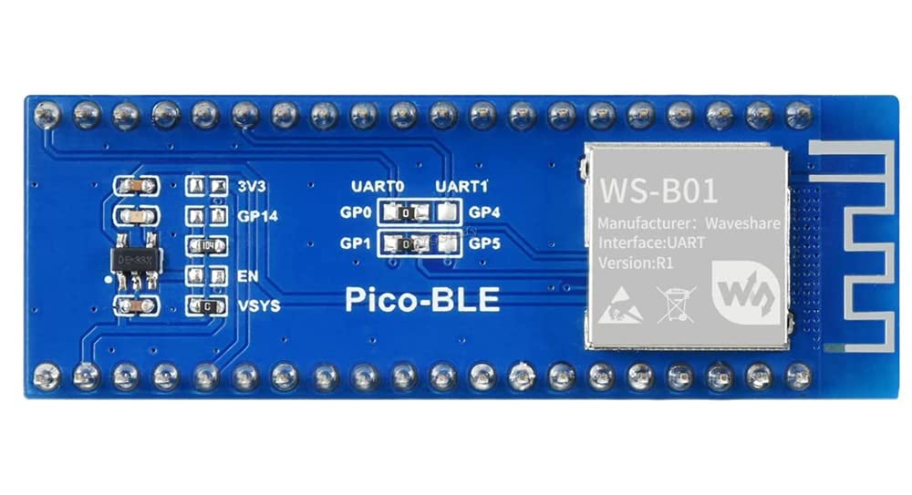

Bluetooth module